BIT BY BIT CODING
Term 1 Impact Report
April to June 2026 | Offline (with Google Colab) | Singapore
Prepared for: BbB ExCo, Temasek Foundation, Singapore Government Partnerships Office, *SCAPE and other partners
33  Applicants  registered | 15  Completed term  and survey | 100%  More confident  in coding | 93%  More likely to  pursue coding | 87%  Want to continue  with BbB

1. Executive Summary
Bit by Bit Coding (BbB) is a free, community-run coding education programme for Singaporean youth aged 13 to 18, founded in January 2026. BbB exists to close the gap between government-provided introductory coding programmes and the advanced, industry-grade curriculum that currently sits behind $300 to $500 per month paywalls in Singapore's private enrichment sector.
Term 1 was BbB's first full 12-week cohort. It ran from May to July 2026, delivered online via Google Colab, and covered Python fundamentals through object-oriented programming, data representation, and a Grand Challenge capstone project. The term attracted 33 applicants, of whom 15 completed the full term and the post-term feedback survey. Every single respondent left more confident in coding than when they started.
The data from Term 1 builds on what the March Bootcamp showed. The demand is real, the pedagogy works, and the students it serves are the ones it set out to reach. 80% of Term 1 respondents were first-time coders. 100% reported increased confidence. 93% said the programme made them more likely to pursue coding further. And 87% want to continue learning with BbB specifically.
This report presents the evidence, the honest challenges, and what BbB is doing about them.

Why This Matters
Singapore's coding education landscape has a structural gap. Government programmes like Code for Fun and Code in the Community introduce the basics. Private enrichment bridges the gap to industry tools, but at $300 to $500+ per month. BbB is the free bridge between those two worlds.
Term 1 is proof that the model holds up beyond a single bootcamp. A 12-week sustained curriculum, delivered entirely by volunteers, at zero cost to students, produced measurable learning outcomes and a retention rate that most paid programmes in Singapore would be happy with.
2. About Bit by Bit Coding
Mission
To democratise advanced coding education for all Singaporean youth aged 13 to 18, empowering them to create technology solutions that benefit their own lives and the communities around them.
What Makes BbB Different
- Completely free. No fees, no means-testing, no premium track. Open to any youth aged 13 to 18.
- Multi-year curriculum. A structured pathway from beginner Python to AI/ML, not a one-off workshop.
- Social impact built in. Students build real tools for non-profit partners as part of the advanced curriculum.
- Research-grounded pedagogy. Constructionist learning (Papert), learner-centred design (Guzdial), and scaffolded project-based practice.
- Endorsed. Curriculum endorsed by two VJC computing teachers. Pedagogy advised on and praised by a professor of coding education at Cornell University.

3. Term 1 Overview
Detail | Information
Duration | 12 weeks (May to July 2026)
Format | Offline with Google Colab
Curriculum | Python fundamentals: variables, data types, control flow, loops, data structures, functions and recursion, file I/O, mini library project, searching and sorting, OOP, data representation
Capstone | Grand Challenge project (2 weeks)
Cost to students | Free
Tutors | Volunteer tutors (H2 Computing alumni, NUS CS/Maths students)
Applicants registered | 33
Completed term and survey | 15
First-time coders | 80% (12 of 15 surveyed)
March Bootcamp alumni | 4 of 33 applicants

Term 1 was designed as a 12-week introduction to Python, moving from absolute basics (variables, data types) through to intermediate concepts (OOP, searching and sorting, data representation) and ending with a two-week Grand Challenge capstone where students built a project of their choosing. The term was delivered entirely online via Google Colab, which kept costs at zero. Holding our programme at *SCAPE and WeWork also allowed us to keep costs at zero. Our sole budget spendings were: (a) extension cords for the students in class, (b) BbB T-shirts for the tutors, and (c) prizes for the hackathon winners.
Of the 33 students who registered, 15 completed the full term and submitted the end-of-term feedback survey. This 45% completion rate is consistent with free community programmes where students self-select and are not penalised for dropping out. The 15 who completed are the sample base for the learning and feedback data in this report. With this data, we can further improve our programme to reduce dropout rates from students.

4. Participant Demographics and Reach
4.1 Age Distribution
All 33 applicants provided their date of birth. Ages ranged from 14.5 to 23.6 years, with a mean of 18.2. 14 applicants (42%) fell within BbB's target range of 13 to 18. 18 applicants (55%) were aged 19 to 22, primarily polytechnic and university students or those between NS and university. One applicant was aged 23.
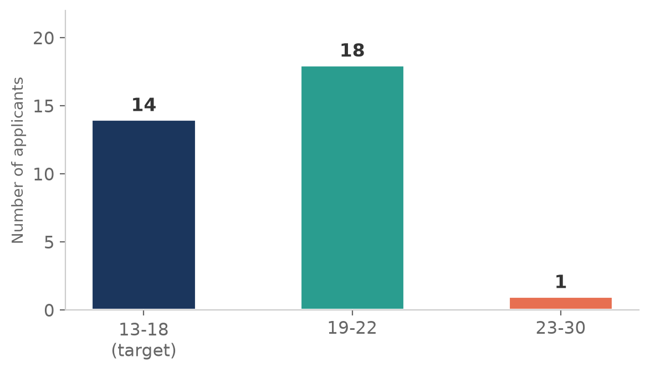
Figure 1: Age distribution of Term 1 applicants (n=33)
The age skew towards 19 to 22 mirrors what BbB saw at the March Bootcamp. It confirms that the coding education gap BbB addresses is not limited to secondary school students. Young adults in polytechnic, university, and post-NS transitions are also looking for free, structured coding education. BbB's mission remains focused on ages 13 to 18, but the demand from young adults is a signal worth noting.

4.2 Education Status
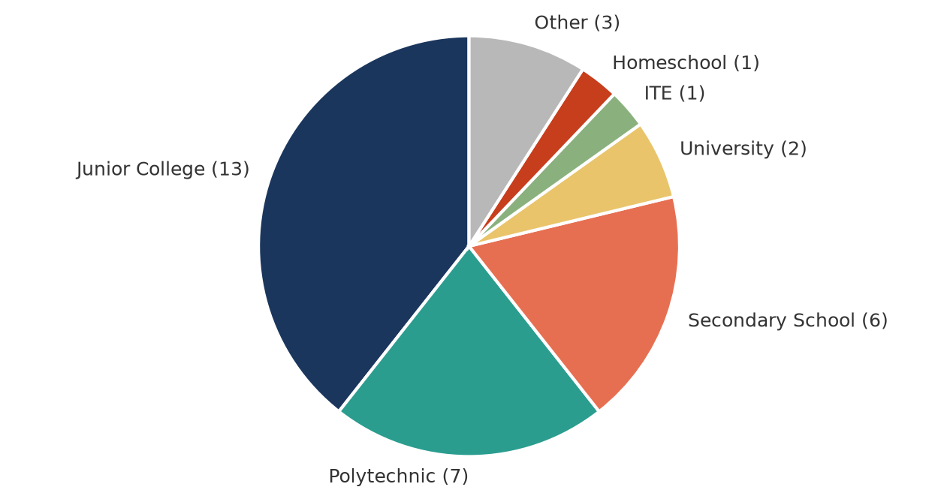
Figure 2: School type distribution of Term 1 applicants (n=33)
Junior College students made up the largest group (13 applicants), followed by polytechnic students (7) and secondary school students (6). Two applicants were university students, one was from ITE, one was homeschooled, and three listed "Other” or “None”. The JC majority is consistent with the March Bootcamp and suggests that BbB's outreach channels (Reddit, word of mouth) are currently reaching academically engaged students. Reaching lower-income secondary schools more effectively remains a priority for Term 2.

4.3 Gender
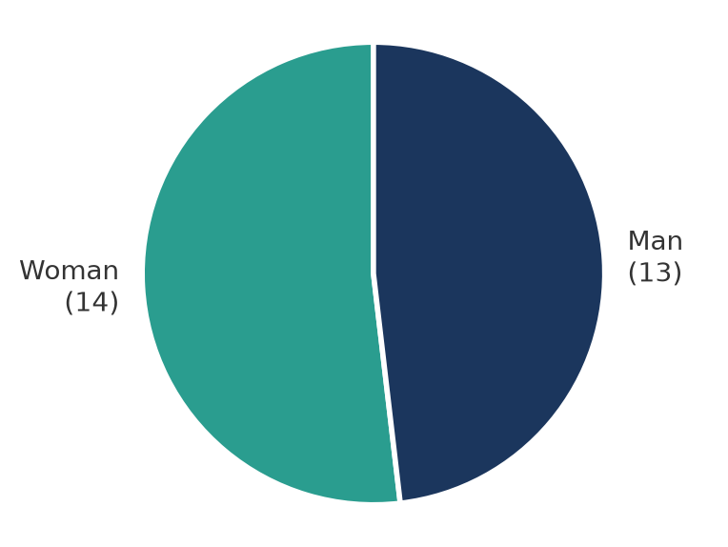
Figure 3: Gender distribution of pre-event survey respondents (n=27)
Gender split was nearly even: 14 women and 13 men responded to the pre-event survey. This is notable for a coding programme. National STEM participation data in Singapore tends to skew male, particularly in computer science. BbB's near-parity split suggests that free, community-grounded outreach may reach young women more effectively than traditional computing enrichment channels. This is a goal we shall continue working towards.
4.4 Ethnicity
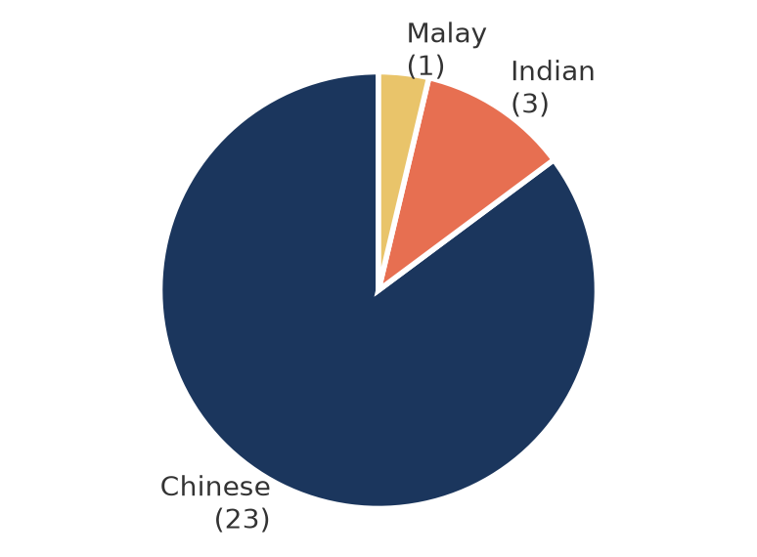
Figure 4: Ethnicity of pre-event survey respondents (n=27)
Of 27 pre-event survey respondents, 23 identified as Chinese, 3 as Indian, and 1 as Malay. BbB notes that this skew towards Chinese respondents reflects the outreach channels used (Reddit, Instagram, word of mouth) rather than explicit targeting. Reaching Malay, minority, and lower-income communities more effectively is a strategic priority for Term 2, including through ComLink+ and Educado SDC referrals.
4.5 Socioeconomic Reach
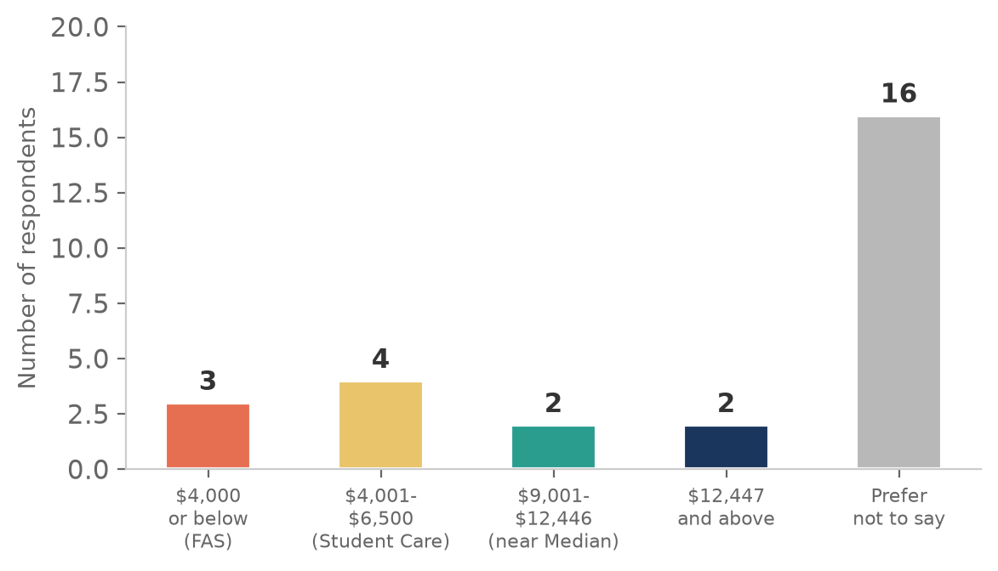
Figure 5: Gross monthly household income distribution (n=27, pre-event survey)
Income data should be interpreted with caution. 59% of respondents (16 of 27) chose “Prefer not to say” for gross household income. This is common in community surveys and does not imply higher-income skew.
Of the 11 respondents who disclosed household income: 3 (27%) fall at or below $4,000 per month, meeting the MOE Financial Assistance Scheme baseline. 4 (36%) are in the $4,001 to $6,500 range, meeting the Student Care Fee Assistance threshold. 2 (18%) are in the $9,001 to $12,446 range, and 2 (18%) are above $12,447. In total, 7 of 11 disclosing respondents (64% of disclosures) have household income below $9,000 per month, within the range of common government assistance thresholds.
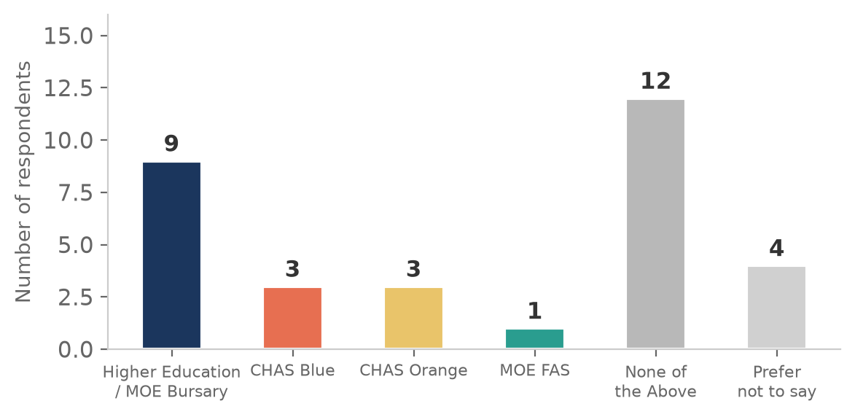
Figure 6: Community assistance scheme participation (n=27)
41% of pre-event survey respondents indicated receiving at least one community assistance scheme: 9 receive the Higher Education or MOE Bursary, 3 hold a CHAS Blue Card, 3 hold a CHAS Orange Card, and 1 receives MOE FAS. A further 15% preferred not to say. While BbB does not means-test, this confirms that the programme is reaching students from households that access government support schemes. This is a meaningful signal given that BbB had not yet formalised partnerships with MSF or ComLink+ during Term 1.

5. Outreach and Recruitment
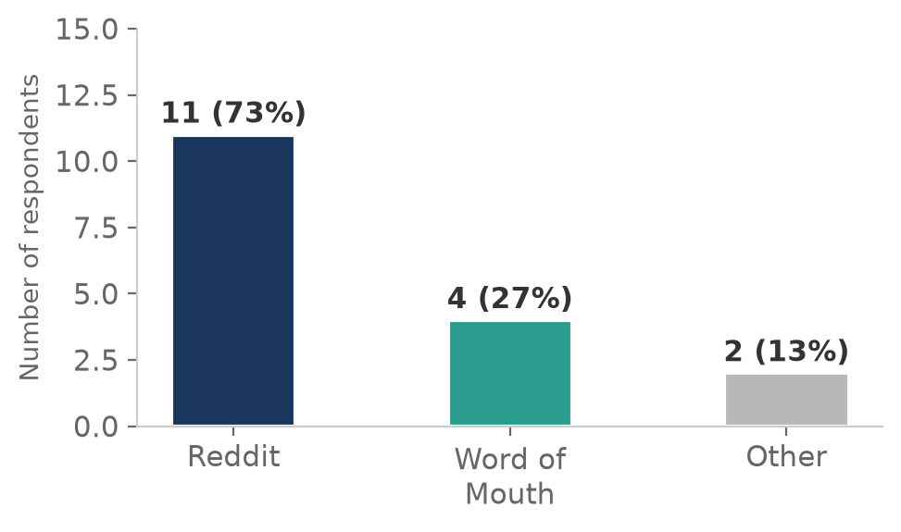
Figure 7: How Term 1 respondents heard about BbB (n=15, multi-select)
Reddit remained the dominant acquisition channel for Term 1, consistent with Bootcamp findings, accounting for 73% of feedback survey respondents (11 of 15). Word of mouth contributed 27% (4 respondents). No respondents came from Educado, school referrals, or paid channels.
This mirrors the March Bootcamp finding, where a single Reddit post in r/singapore drove 77% of sign-ups. For Term 1, Reddit continued to be the primary funnel without any additional paid advertising or institutional referral pipeline. The consistency across both cohorts suggests that Reddit is not a one-off channel but a reliable acquisition source for BbB's audience.
For Term 2, BbB should continue maintaining an authentic Reddit presence and explore subreddits targeting disadvantaged youth, parents, and student communities. Word of mouth will likely grow as the Term 1 cohort refers friends, but the data does not yet show this effect at scale.

6. Learning Impact
Post-term survey data from 15 respondents across three core learning dimensions: accessibility for beginners, confidence in applying concepts, and clarity of explanations.
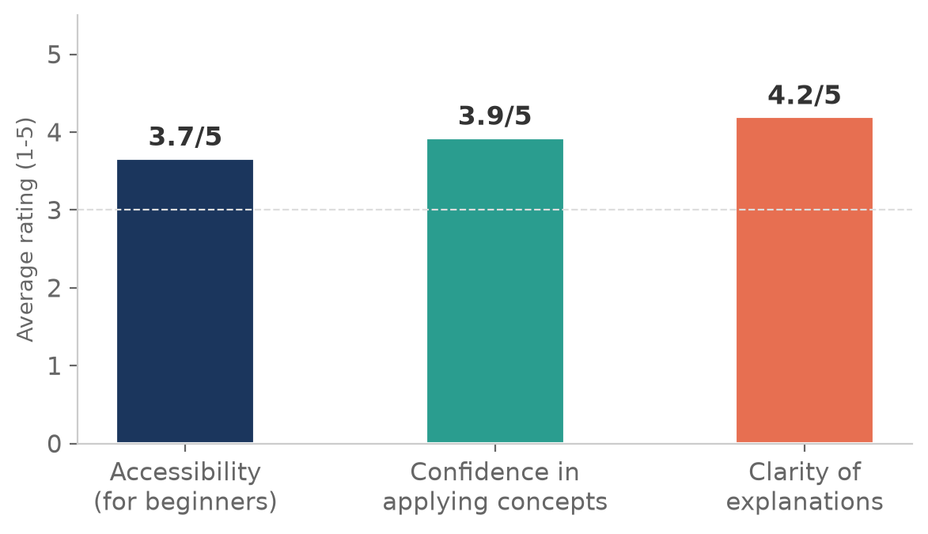
Figure 8: Average ratings across key learning dimensions (1-5 scale)
6.1 Accessibility for Beginners
Survey question asked of the 12 respondents who identified as first-time coders. The average accessibility rating was 4.1 out of 5. 8 of 12 rated it 4 or 5 (accessible or highly accessible). 3 rated it 3 (neutral). 1 rated it 2 (found it somewhat inaccessible). Zero rated it 1.
This is a core validation metric. BbB is built for complete beginners, and the data shows that 67% of first-time coders found the lessons accessible or highly accessible. The lone low rating is worth noting: one student with zero coding background found it hard to follow without guidance, and specifically asked for the pacing to be slower. This is the same signal the March Bootcamp data showed, and BbB is addressing it by extending Term 2 from 12 to 16 weeks.
More specifically, the addition of the 4-week taster will seek to improve inter-cohort bonding and build foundational programming concepts and knowledge. The 4-weeks will aim to smoothen the learning curve and make easing into text-based programming easier from visual programming.
6.2 Confidence in Applying Concepts
Average confidence rating was 3.9 out of 5 across all 15 respondents. 9 rated themselves 4 or 5 (confident or very confident). 5 rated themselves 3 (neutral). 1 rated themselves 3 with the caveat that they have zero coding background but are grateful for the tutor support. Zero rated themselves 1 or 2.
6.3 Clarity of Explanations
Average clarity rating was 4.1 out of 5. 11 of 15 rated tutor explanations as 4 or 5 (clear or very clear). 4 rated them 3 (neutral). Zero rated them 1 or 2 (unclear). The qualitative feedback reinforces this: respondents praised the tutors' approachability, patience, and willingness to help.

7. Per-Lesson Clarity Ratings
Students rated the clarity of each lesson on a 1 to 5 scale. The chart below shows the average rating for each of the 9 lessons taught in Term 1.
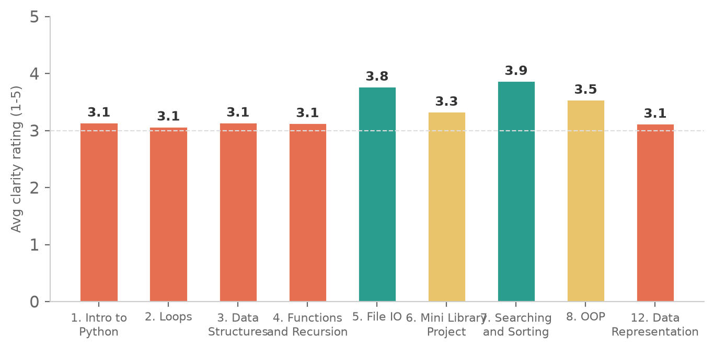
Figure 9: Average clarity ratings per lesson (1-5 scale, n=8 to 15 per lesson)
Searching and Sorting rated highest at 3.87, followed by File IO at 3.77 and OOP at 3.54. The lowest-rated lessons were Loops (3.07), Data Representation (3.12), and Intro to Python (3.14).
The pattern here is informative. Early lessons (Intro, Loops, Data Structures) rated lower, which may reflect students adjusting to the learning environment and the basics of Python. The mid-term lessons (File IO, Searching and Sorting) rated higher, suggesting that students found their footing as the term progressed. OOP and Data Representation sit in between, which is consistent with these being the more conceptually demanding topics requiring students to visualise relatively difficult programming concepts.
When asked which lessons could have been clearer, students most frequently cited File IO (6 mentions), Searching and Sorting (5 mentions), and OOP (4 mentions). The qualitative comments point to two issues: pacing (the lessons moved too quickly for beginners to process) and GitHub setup (several students found the GitHub and Codespace setup confusing and not intuitive).
"I didn't understand when to use classes and what's the purpose. Concept was unclear."
"GitHub was a little rushed. Mini Library Project felt a little early for me as my foundation was still not too strong."

8. Weekly Challenges and Extra Practices
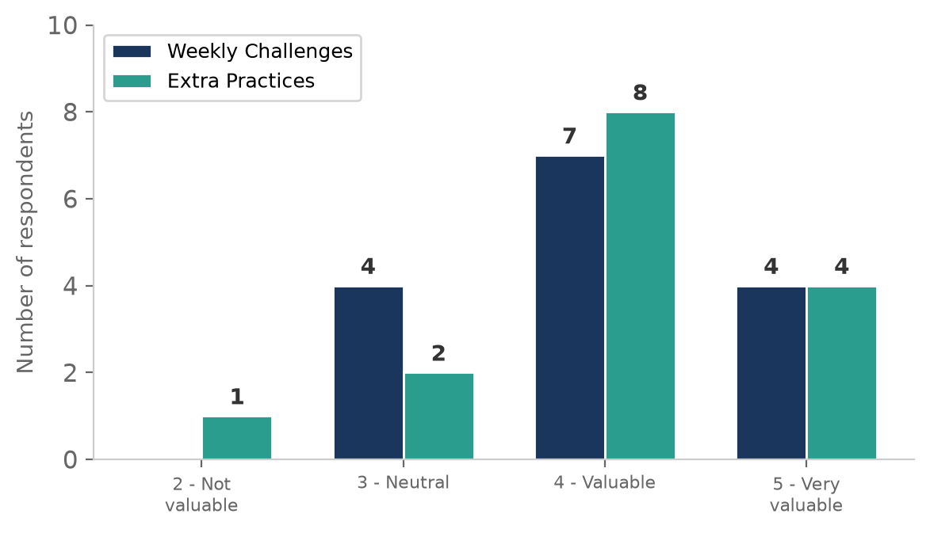
Figure 10: How students rated the value of weekly Challenges and Extra Practices (1-5 scale)
Both weekly Challenges and Extra Practices rated well. For Challenges, 11 of 15 respondents rated them 4 or 5 (valuable or very valuable). For Extra Practices, 12 of 15 rated them 4 or 5. Only 1 respondent rated Extra Practices as not valuable (2 out of 5).
Engagement was regular but not intensive. 8 respondents attempted some questions every week. 6 attempted some questions for some of the weeks. Only 1 attempted all or most of the questions every week. This suggests that the practice material is seen as useful by those who engage, but that time constraints limit how much students can do. Shorter, bite-sized questions may help such students, and we look towards experimenting with various means of engagement outside of class.

8.1 Difficulties with Engagement
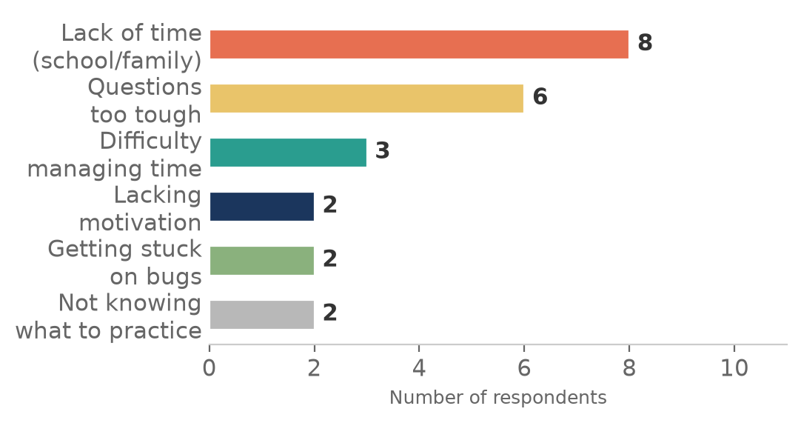
Figure 11: Factors that made engagement with Challenges and Extra Practices difficult (n=15, multi-select)
Lack of time due to school, family, or other commitments was the dominant factor, cited by 10 respondents. This is consistent with the age profile: most Term 1 students are in JC or polytechnic, where academic pressure is high. 6 respondents found the questions too tough. 3 cited difficulty managing their time, 2 lacked motivation or felt burnt out, and 2 got stuck on bugs without immediate help.
This gives us some insight as to why some students were not attempting challenges outside of class. The top two causes suggest a mixed approach of (a) shorter and more bite-sized questions consistent with privately offered courses on Brilliant.org, and (b) better guardrails and scaffolding to ensure students can persist even when they get stuck. Getting unstuck and knowing what to practice seems to be a common theme as well. A possible solution is more interactive and personalized practice, possibly powered by artificial intelligence (AI) tools.
These factors also highlight the importance of teaching students how to learn on their own with the aid of AI tools.

9. Study Habits Outside Class
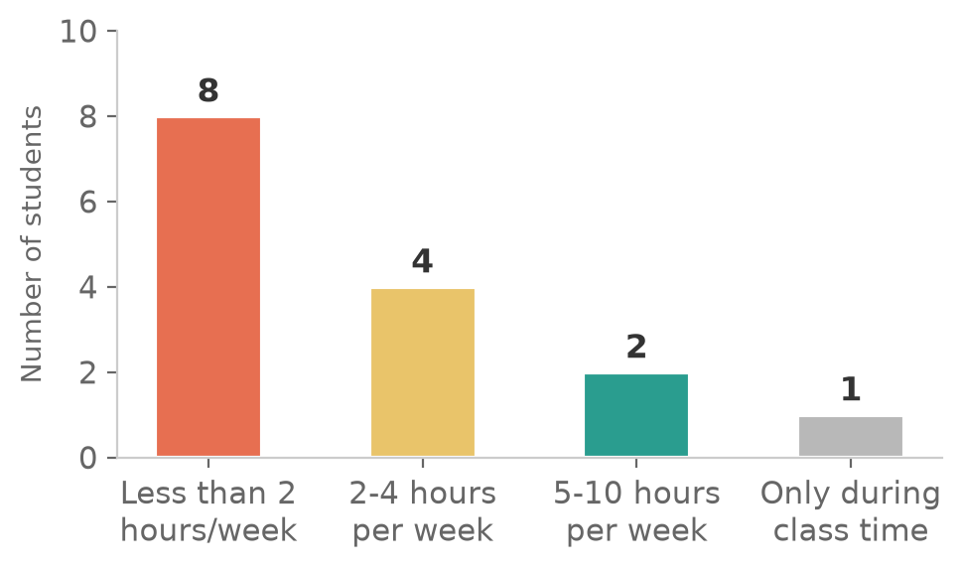
Figure 12: Hours per week spent reviewing lessons or practicing coding outside class (n=15)
More than half the cohort (8 of 15) spent less than 2 hours per week coding outside class. 4 spent 2 to 4 hours. 2 spent 5 to 10 hours. 1 only coded during class time.
This is not surprising for a free, no-stakes programme. But it does point to a structural challenge: the students who improve fastest are the ones who practise most, and the students who practise most are the ones with the most free time. BbB's Curriculum team is exploring ways to build more in-class practice time rather than relying on self-directed study, particularly for students whose school or family commitments limit out-of-class hours.
When asked what made it difficult to study outside class, the dominant responses were lack of time (8), difficulty managing time (3), lacking motivation or feeling burnt out (2), getting stuck on bugs without immediate help (2), and not knowing what to practice (2). PDF notes would have helped: 7 of 15 respondents said they would have preferred PDF notes alongside the demo notebooks, while 8 felt the demo notebooks were sufficient.

10. Behavioural and Mindset Outcomes
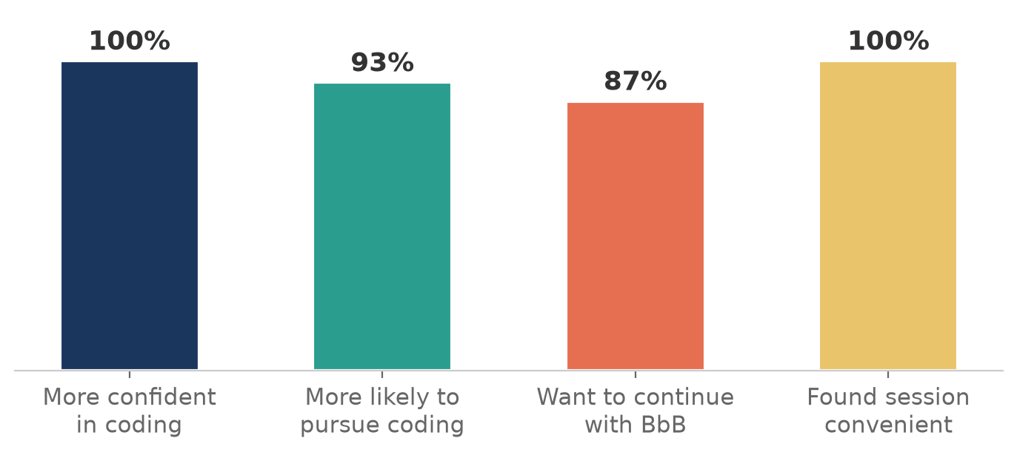
Figure 13: Headline outcome metrics from Term 1 (n=15)
Three headline metrics stand out. 100% of respondents reported increased confidence in their ability to code. 93% said the lessons made them more likely to explore coding further. 87% want to continue learning with BbB specifically. All 15 respondents found the session timings and location convenient.
These are not self-reported aspirations. They reflect 12 weeks of sustained engagement with a structured curriculum. A 100% confidence increase rate from a cohort where 80% had never coded before is the most important single number in this report.
Qualitative themes from student feedback
Theme 1: Basics feeling solid
"Before Bit by Bit I didn't know about any Python functions. I only knew print(). So this helped me learn a lot about the other kinds of Python functions and the ways you can apply and use them in real life."
"I went from no knowledge to actually being able to code something simple."
"It really helped to build my foundation in Python and the basic concepts. The practice questions provided the means for me to apply these concepts into actual questions."
Theme 2: Realising coding is approachable
Several students arrived expecting coding to be locked behind a paywall or a university degree. Leaving with working code they wrote themselves changed that perception.
"It is a great way to start learning code with zero background. The tutors are really dedicated and patient in helping us. They always ensure that everyone in the class understands what they are explaining."
"Compared to self-learning, learning under the guidance of an experienced mentor with a structured roadmap helps me to stay on the right track."
Theme 3: Tutor quality as the differentiator
Tutor approachability and responsiveness was the most frequently cited factor in confidence gain. Students valued both the technical accuracy and the interpersonal warmth of the teaching team.
"I have zero experience in coding, so it was really hard for me to follow without guidance. But I am really grateful that the tutors here are really dedicated and patient in helping us."

11. Grand Challenge
The Grand Challenge was a two-week capstone project at the end of Term 1. Students chose from a set of prompts or proposed their own, then built a Python project that applied the concepts they had learned. The challenge ended with a presentation session where students showcased their work and received feedback from industry experts.
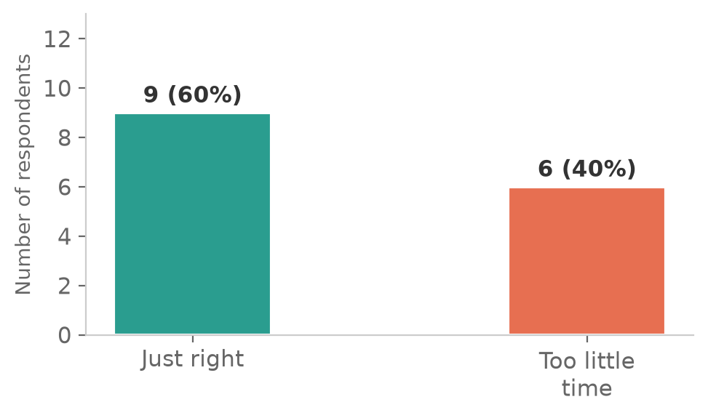
Figure 14: Was the time given to complete the Grand Challenge sufficient? (n=15)
9 of 15 respondents felt the two weeks given for the Grand Challenge was just right. 6 felt it was too little. No one felt there was too much time. The 60/40 split suggests that two weeks is workable for most students but tight for those with heavier school commitments.
On project requirements: 13 of 15 found the requirements clear, 8 found them feasible, and 0 found them neither clear nor feasible. This is a strong result for a first-time capstone format.
What students enjoyed
"My favourite part was being able to choose any idea we wanted and being given the freedom to explore different problems that a simple Python code could fix."
"Receiving feedback from industry experts. As someone who is just starting to learn Python, getting personalised feedback on a project that I had worked on was very meaningful. It gave me insights that are difficult to gain through self-learning alone."
"Being able to work on a project from scratch."
Suggestions for improvement
"Maybe can show us a sample piece of work before starting so we know what the expected deliverables are."
"I think a suggestion would be to consider limiting the Grand Challenge to students who attended the lessons. As the challenge was open to everyone, there was quite a wide range of skill levels, which made the competition a little less balanced."
"More time given to brainstorm for the challenge."

12. Areas for Improvement
Feedback has been distilled into five actionable categories. BbB is acting on all of them before Term 2 begins.
Area | What students said | What BbB is doing
Pacing and lesson timing | Several students found lessons rushed, particularly File IO, OOP, and the GitHub setup. Some felt the Saturday morning slot was too early. | Extending Term 2 from 12 to 16 weeks to reduce content density. Building in more pause-and-practice moments. Reviewing the start time.
Difficulty of practice questions | 6 of 15 found the practice questions too tough. Some felt a gap between lesson content and challenge difficulty. | Adding practice questions at varying difficulty levels (Level 1 to Level 3) for Term 2.
Notes format | Nearly half the cohort (7 of 15) would have preferred PDF notes alongside the demo notebooks. | BbB will offer PDF notes as a supplement in Term 2 while keeping the demo notebooks as the primary material.
Git and Codespace setup | Multiple students found GitHub and Codespace confusing, saying the setup was not intuitive. | Creating a step-by-step onboarding guide for Git and Codespace. Adding a dedicated setup session at the start of Term 2.
Grand Challenge fairness | One student noted the wide skill range in the Grand Challenge made judging feel uneven. Another asked for sample projects. | Restricting Grand Challenge participation to students who attended the lessons. Providing sample projects before the challenge begins.

Reflection on pacing
Pacing was the number one issue identified in the March Bootcamp data, and it remains the number one issue in Term 1. The pattern is clear: students who are learning to code for the first time need more time to absorb, practise, and revisit concepts than a 12-week schedule allows. BbB is responding by extending the term to 16 weeks and removing two of the less critical lessons to create more breathing room.

13. Retention and Future Pipeline
13 of 15 surveyed respondents (87%) said they want to continue learning with BbB. 2 said no. This is a strong retention signal for a first full term, particularly given that the programme is free, ungraded, and has no penalty for leaving.
Combined with the 93% who said the programme made them more likely to explore coding further, this indicates that Term 1 produced not just short-term confidence but a stated commitment to continue. 4 of the 33 Term 1 applicants had attended the March Bootcamp, suggesting that the bootcamp-to-term conversion pipeline works but is still small.
For Term 2, BbB plans to: invite all 15 completing Term 1 students to continue, open registration to new students including March Bootcamp attendees who did not join Term 1, and pilot the extended 16-week format.
Programme sustainability signal
An 87% retention intent rate from a first full term, delivered entirely by volunteers at zero cost, with no paid marketing and no institutional backing, is a strong early signal. If BbB can maintain this through Term 2, the cohort model becomes self-sustaining through word-of-mouth and genuine student satisfaction.
14. Key Insights and Strategic Takeaways
Insight 1: The pedagogy model holds up over 12 weeks
The March Bootcamp proved it in 3 hours. Term 1 proves it over 12 weeks. 100% confidence increase, 93% more likely to pursue coding, 87% want to continue. The constructionist, project-based approach works at scale, not just in a single session.
Insight 2: Tutor quality is the programme's core asset
Across both the Bootcamp and Term 1, tutor approachability and responsiveness is the most frequently cited reason for confidence gain. This is something self-directed online platforms cannot replicate. BbB's volunteer tutor model is not just a cost solution, it is a pedagogical differentiator.
Insight 3: Pacing is the persistent risk
55% of Bootcamp attendees found the lesson too fast. In Term 1, the same signal appeared: students asked for slower pacing, more practice time, and more gradual progression. Extending to 16 weeks is the direct response. This is now a first-principles curriculum design input, not a tweak.
Insight 4: Reddit continues to be the dominant channel
73% of Term 1 respondents came from Reddit, consistent with the Bootcamp's 77%. Reddit is a reliable, high-intent, high-trust acquisition channel for BbB's audience. For Term 2, BbB should maintain an authentic Reddit presence and explore targeted posts in student-focused and lower-income-focused subreddits.
Insight 5: The programme is reaching lower-income youth
41% of pre-event survey respondents receive at least one community assistance scheme. Without formal ComLink+ or MSF partnerships, BbB is already reaching students who need free education most. Formalising these partnerships for Term 2 will amplify this reach.
Insight 6: Gender parity is achievable in free coding education
A 52/48 female-to-male split in a coding programme is unusual. BbB's no-barriers, community-grounded approach may reach young women more effectively than traditional computing enrichment channels. This is worth monitoring and protecting as the programme scales.

15. Conclusion
Term 1 was BbB's first sustained cohort. Over 12 weeks, with a volunteer team, at zero cost to students:
- 33 students applied. 15 completed the end-of-term survey.
- 80% had never coded before. 100% left more confident.
- 93% are more likely to pursue coding further.
- 87% want to continue learning with BbB specifically.
- 41% of surveyed students receive community assistance, without any formal referral pipeline.

BbB is still an early-stage organisation. The team is small, the budget is zero, and the programme is still iterating. But the Term 1 data shows the model works beyond a one-off bootcamp. The demand is real across age groups. The pedagogy is producing measurable outcomes. And the students it reaches are the ones it set out to serve.
With funding support from Temasek Foundation, the National Youth Council, and the Singapore Government Partnerships Office, BbB can scale from a scrappy groundup into a sustainable, multi-year coding education institution for Singapore's youth, one that fills the gap no one else is filling, and keeps filling it for free.

BbB's commitment
Every young person who wants to learn to code should be able to learn to code, regardless of household income, school, gender, or background. No student is turned away for financial reasons. No means-testing. No barriers beyond curiosity and commitment.
At the same time, we are also building a community of inspiring students, professionals and changemakers looking to create a space for youths to explore, to learn, to grow, and then to sail. For far too long, coding has been locked behind stereotypes (of what it is, and who gets to learn it) and expensive programmes. Bit by Bit aims to shatter those misconceptions and build a community of like-minded youths and mentors who believe that coding is not just a hobby, but a tool for tangible social change. We believe that Bit by Bit is, in some tangible, meaningful way, a revolution in the way that we think about coding, and about who gets to learn it.
Let’s open the doors to coding education, wider, together, for all-time, #BitbyBit.

